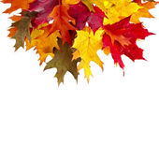

**“Follow the Road to Success with Continuing Education”**

**FALL 2019 CBDIAI SEMINAR - TENTATIVE AGENDA**

**OCTOBER 12, 2019**

***Track A – Practitioners/Experts (MAX 20)***

8am-11:45am – Observation, Inference and Bias – Kelly Ayers, West Virginia University

11:45am – 1pm Lunch

1pm – 4pm – Evidence Detection across the Spectrum: Using Forensics Light Sources from 254nm to over 1µm (>1000nm) – Walter Hiller, SPEX Forensics

***Track B – Practitioners / Experts / Students***

8:00am – 9:00am – Development of Blood Impressions on Tape – Carlie Hayes, Federal Government and Sergio Ramirez, DC Department of Forensic Science (DFS)

9:00am – 10:00am - Investigating Flex Seal for Impression Recovery – Cory Bartoe, Virginia Department of Forensic Science (VA DFS)

10:00am-11:45am – A Dialog on the Effectiveness of LatentSleuth on Difficult Latents and Statistical Error Estimation for an Objective Measure of Similarity to a Latent Image – Jessica J. Davis, Forensic Scientist Supervisor DFS, Anneliese E. L. Deitz Forensic Scientist Latent Prints VA DFS, Richard Smith, VP Products and Services, Dr. Donald Gantz, Professor Emeritus of Statistics

11:45am – 1pm Lunch

1pm-2pm – 3D Crime Scene Documentation – Gabby Toy, Anne Arundel County Police Department

2pm-4pm – Insights into the Hiring Process from a Supervisors Prospective – Julissa Armstrong, Suffolk PD and Dade Chisler, Virginia Beach PD

**Track C – Students / Trainees / New to Crime Scene (30 Max)**

Introduction to Crime Scene Documentation – Andrew Reitnauer, Delta Forensics, and Gabby Toy, Anne Arundel County Police Department

8am – 11:45am – Documenting a Crime Scene including photography, sketching and documentation

11:45am-1pm – Lunch

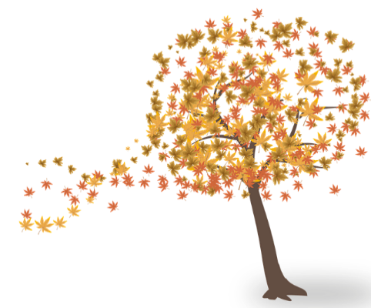1pm-4pm – Mock Crime Scene